SELF-DRIVING CAR: EMBEDDED SYSTEM DESIGN PROJECT
Advanced Driver Assistance Systems (ADAS)
B.Tech Computer Science and Engineering
Name: Ayushman Sahoo
Reg. No.: 12211169

Chapter-1

Introduction

1.1 Project Overview
The Self-Driving Car Embedded System Design Project is a comprehensive implementation of an autonomous vehicle prototype that demonstrates the integration of multiple advanced technologies including sensor fusion, real-time image processing, machine learning algorithms, and embedded systems programming. This project showcases the practical application of computer vision, hardware interfacing, and autonomous navigation capabilities through a functional prototype vehicle. The system is powered by a dual-processor architecture combining a Raspberry Pi 4 for high-level processing and decision-making with a TIVA C microcontroller for real-time motor control and sensor interfacing. The integration of multiple sensors including ultrasonic sensors, infrared sensors, and an 8MP camera module enables comprehensive environmental perception and accurate obstacle detection.

1.2 Background and Importance
The field of autonomous vehicles represents one of the most significant technological advancements of the 21st century. Autonomous driving systems are designed to reduce human error, improve road safety, enhance transportation efficiency, and provide mobility solutions for people with disabilities. The development of Advanced Driver Assistance Systems (ADAS) forms the foundation of fully autonomous vehicles. ADAS technologies such as adaptive cruise control, lane keeping assist, automatic emergency braking, and blind spot warning are already deployed in modern vehicles, contributing to safer driving experiences. Understanding the principles and implementation of these systems is crucial for engineers and researchers working in the automotive and embedded systems domains. This project provides practical insights into the challenges and solutions involved in creating an autonomous navigation system, including real-time image processing at 30 frames per second, multi-sensor data fusion, and decision-making algorithms that must operate reliably under various environmental conditions.

1.3 Project Objectives
The primary objectives of this project are as follows:
- To design and implement a multi-sensor autonomous vehicle system capable of real-time environmental perception and navigation.
- To develop efficient image processing algorithms using OpenCV4 for traffic light detection, stop sign recognition, obstacle detection, and lane boundary identification.
- To implement machine learning models including cascade classifiers and convolutional neural networks for accurate object recognition.
- To establish effective communication between high-level processing unit (Raspberry Pi 4) and real-time control unit (TIVA C microcontroller) via UART serial communication.
- To demonstrate autonomous navigation capabilities including obstacle avoidance, traffic sign recognition, and lane keeping functionality.
- To achieve real-time performance metrics with frame processing at 30 FPS, detection accuracy of 94.5%, and response latency below 100 milliseconds.

1.4 Methodology Overview
This project employs a systematic approach to autonomous vehicle development, combining hardware integration, software development, and algorithm implementation. The methodology consists of four main phases: hardware selection and configuration, embedded software development, image processing and machine learning implementation, and system integration and testing. During the hardware phase, appropriate sensors, microcontrollers, and mechanical components were selected based on project requirements and performance specifications. The software phase involved configuring both the Raspberry Pi 4 operating system and TIVA C microcontroller firmware, establishing communication protocols, and implementing driver libraries for all peripherals. The image processing phase utilized OpenCV4 for real-time video analysis and feature extraction. Machine learning models were trained on custom datasets and optimized for deployment on the Raspberry Pi 4 using TensorFlow Lite. Finally, all system components were integrated and tested to ensure reliable autonomous operation. The entire development process emphasizes real-time performance, safety-critical decision making, and robust sensor fusion for accurate environmental perception.

Chapter-2

Literature Review

2.1 Autonomous Vehicle Systems
Autonomous vehicle systems represent a complex integration of multiple technologies including perception, decision-making, and control systems. The Society of Automotive Engineers (SAE) defines six levels of vehicle autonomy, ranging from Level 0 (no automation) to Level 5 (full automation under all conditions). Modern autonomous vehicles employ sophisticated sensor arrays including cameras, LIDAR, radar, and ultrasonic sensors to create a comprehensive environmental model. The perception subsystem processes sensor data to detect obstacles, identify road markings, recognize traffic signs, and locate other vehicles. Advanced algorithms such as convolutional neural networks and deep learning models enable accurate real-time object detection and classification. The decision-making subsystem evaluates the perceived environment and determines appropriate actions based on traffic rules, safety considerations, and navigation objectives. The control subsystem then translates these decisions into precise motor commands that control acceleration, braking, and steering.

2.2 Advanced Driver Assistance Systems
Advanced Driver Assistance Systems (ADAS) are a suite of safety and convenience features that assist drivers in vehicle operation and accident prevention. Common ADAS features include Adaptive Cruise Control (ACC), which automatically adjusts vehicle speed to maintain safe following distance; Lane Keep Assist (LKA), which helps maintain proper lane position; Automatic Emergency Braking (AEB), which applies brakes to prevent or mitigate collisions; Blind Spot Warning (BSW), which alerts drivers to vehicles in blind spots; and Traffic Sign Recognition (TSR), which identifies and displays traffic signs to the driver. These systems rely on computer vision algorithms and sensor fusion techniques to accurately perceive the driving environment. Research has demonstrated that properly implemented ADAS features can significantly reduce accident rates and improve overall road safety. The integration of these technologies in prototype vehicles provides valuable research opportunities for understanding sensor-actuator interactions and developing more sophisticated autonomous capabilities.

2.3 Computer Vision and Image Processing
Computer vision is a critical technology for autonomous vehicle systems, enabling real-time perception and understanding of the driving environment. Key image processing techniques include color space conversion, which transforms images between different color models (RGB, HSV, etc.) for optimized feature detection; Gaussian blur, which reduces image noise and facilitates edge detection; Canny edge detection, which identifies significant intensity changes in images; and morphological operations, which enhance image features through erosion and dilation. The Hough Transform is particularly valuable for detecting geometric shapes such as lane markings and traffic signs, while contour analysis enables identification and classification of objects of interest. OpenCV is widely used in computer vision applications, providing optimized implementations of these algorithms. Real-time performance is critical for autonomous vehicles, requiring efficient algorithm implementation and hardware acceleration techniques. Modern systems often employ graphics processing units (GPUs) or specialized hardware accelerators to achieve necessary processing speeds.

2.4 Machine Learning for Object Detection
Machine learning techniques have revolutionized object detection capabilities in autonomous systems. Cascade classifiers, based on the Viola-Jones algorithm, provide fast and accurate detection of specific objects such as traffic signs and pedestrians. Haar-like features and Histogram of Oriented Gradients (HOG) are feature extraction methods that capture distinctive characteristics of objects of interest. Convolutional Neural Networks (CNNs) represent the state-of-the-art in image recognition, offering superior accuracy compared to traditional methods. Deep learning architectures such as AlexNet, VGG, and ResNet have achieved remarkable performance on image classification tasks. For real-time deployment on embedded systems like Raspberry Pi, model optimization techniques including quantization, pruning, and knowledge distillation are employed to reduce computational requirements while maintaining acceptable accuracy levels. TensorFlow Lite provides an efficient framework for deploying neural networks on mobile and embedded devices with limited computational resources.

2.5 Sensor Fusion and Data Integration
Sensor fusion is the process of combining data from multiple sensors to create a comprehensive and accurate representation of the environment. Different sensors provide complementary information: cameras provide detailed visual information, ultrasonic sensors measure distances with good accuracy in short ranges, and infrared sensors enable line tracking. Fusion algorithms combine these diverse data sources, each with unique characteristics and limitations, to generate more reliable and robust perceptions than any single sensor could provide. The Kalman filter is a widely used technique for sensor fusion, providing optimal estimation of system state by minimizing estimation error. Proper synchronization of sensor data is critical, as measurements from different sensors may arrive at different times. The temporal alignment of data and appropriate weighting of sensor measurements based on their reliability and relevance to the current task are essential considerations in effective sensor fusion.

Chapter-3

Conceptual Study and System Design

3.1 Hardware Architecture
The hardware architecture of the autonomous vehicle is built on a dual-processor system that effectively distributes processing tasks based on timing requirements and computational complexity. The Raspberry Pi 4, powered by a Quad-core ARM Cortex-A72 processor running at 1.5 GHz, serves as the primary processing unit responsible for high-level decision making, image processing, and machine learning inference. The TIVA C Series microcontroller, based on an ARM Cortex-M4F processor running at 120 MHz, serves as the secondary processing unit dedicated to real-time motor control, sensor interfacing, and low-level hardware management. This architecture enables parallel processing where the Raspberry Pi 4 handles computationally intensive tasks while the TIVA C manages time-critical real-time operations.

3.2 Sensor Suite and Specifications
The vehicle is equipped with a comprehensive sensor suite enabling multi-modal environmental perception. The 8MP Raspberry Pi Camera Module provides high-quality video capture at 30 frames per second with 640x480 resolution, enabling detailed visual analysis of the driving environment. Ultrasonic sensors (HC-SR04 modules) measure distances in the 2 to 400 centimeter range with accuracy suitable for obstacle detection and proximity assessment. Infrared sensors enable line tracking functionality, allowing the vehicle to follow marked paths on the ground. These sensors operate at different update rates and provide complementary information that is fused to create a comprehensive environmental model. The selection of sensors represents a balance between cost, performance, power consumption, and integration complexity, making them suitable for educational and prototype autonomous vehicle applications.
Figure 1.1: Prototype autonomous vehicle with integrated control circuits and motor drivers.
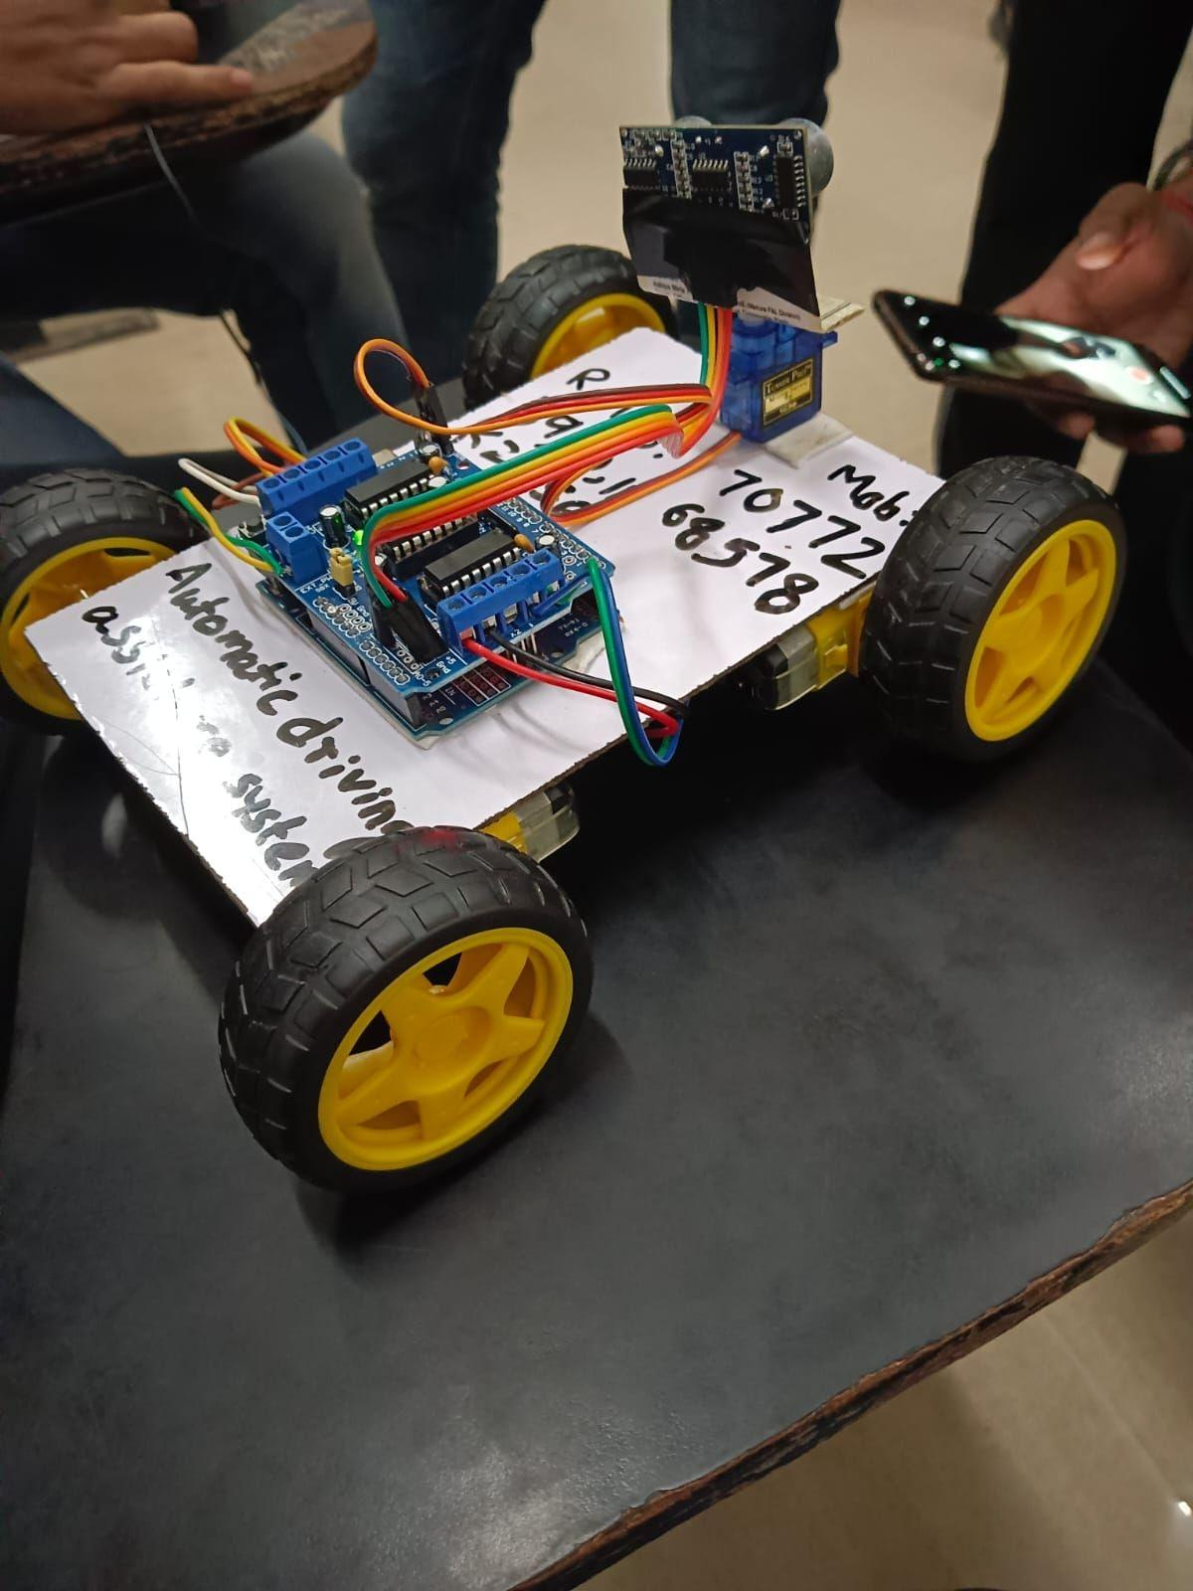

3.3 Actuator Systems and Motor Control
The vehicle employs differential drive mechanics with dual 12V DC motors mounted on the rear wheels, enabling independent speed control for left and right wheels to achieve turning and steering maneuvers. L298N H-Bridge motor driver modules provide bidirectional current control and Pulse Width Modulation (PWM) speed regulation with frequencies up to 25 kHz. This modular approach allows precise control of motor speed and direction, essential for autonomous navigation. Encoder feedback from motor shafts provides odometry information useful for dead reckoning and motion verification. The power system utilizes a 20,000 mAh lithium-polymer battery pack capable of supporting extended operation while maintaining adequate power delivery for motor operation and microcontroller functioning. The mechanical chassis is constructed from aluminum alloy providing structural rigidity while minimizing weight, with rubber tires ensuring adequate traction and shock absorption.
Figure 1.2: Motor driver and sensor integration showing TIVA microcontroller module.
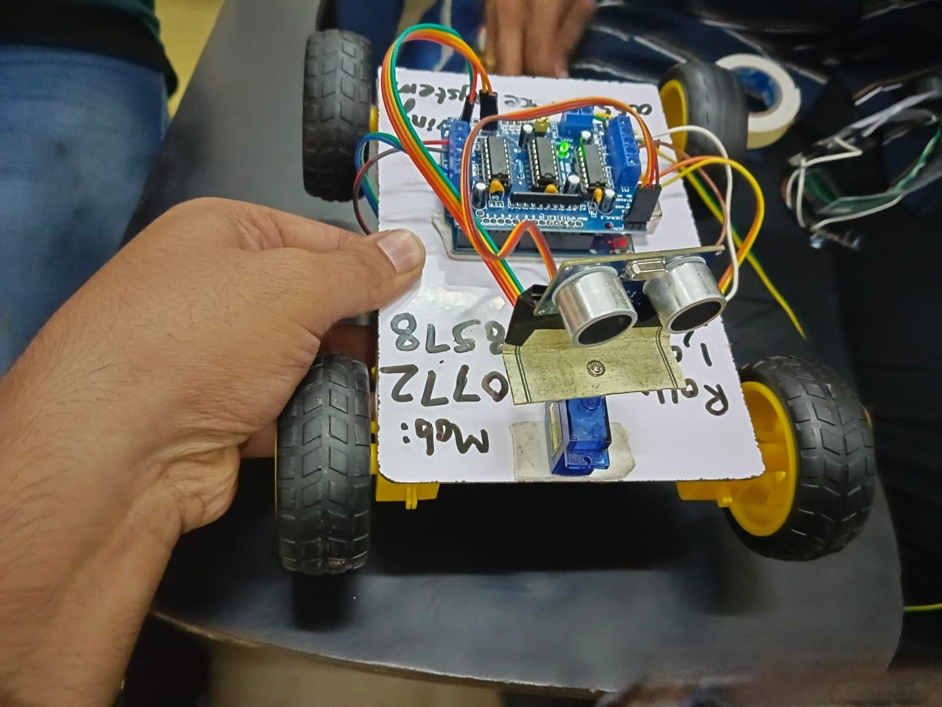

3.4 System Architecture and Data Flow
The system architecture implements a hierarchical control structure with clear separation of concerns. Sensor inputs feed into the perception subsystem running on the Raspberry Pi 4, where image processing and object detection algorithms identify features of interest in the environment. The decision-making subsystem evaluates perceived objects and determines appropriate control actions based on programmed rules and machine learning models. Motor commands are then transmitted via UART serial communication to the TIVA C microcontroller, which translates these commands into PWM signals for motor drivers. Feedback from motor encoders is read by the TIVA C and returned to the Raspberry Pi 4 for motion verification and odometry calculations. This architecture ensures that computationally intensive tasks are performed on the more powerful processor while real-time requirements are met by the dedicated microcontroller.
Figure 1.3: Complete system architecture and wiring diagram showing all major components and their connections.
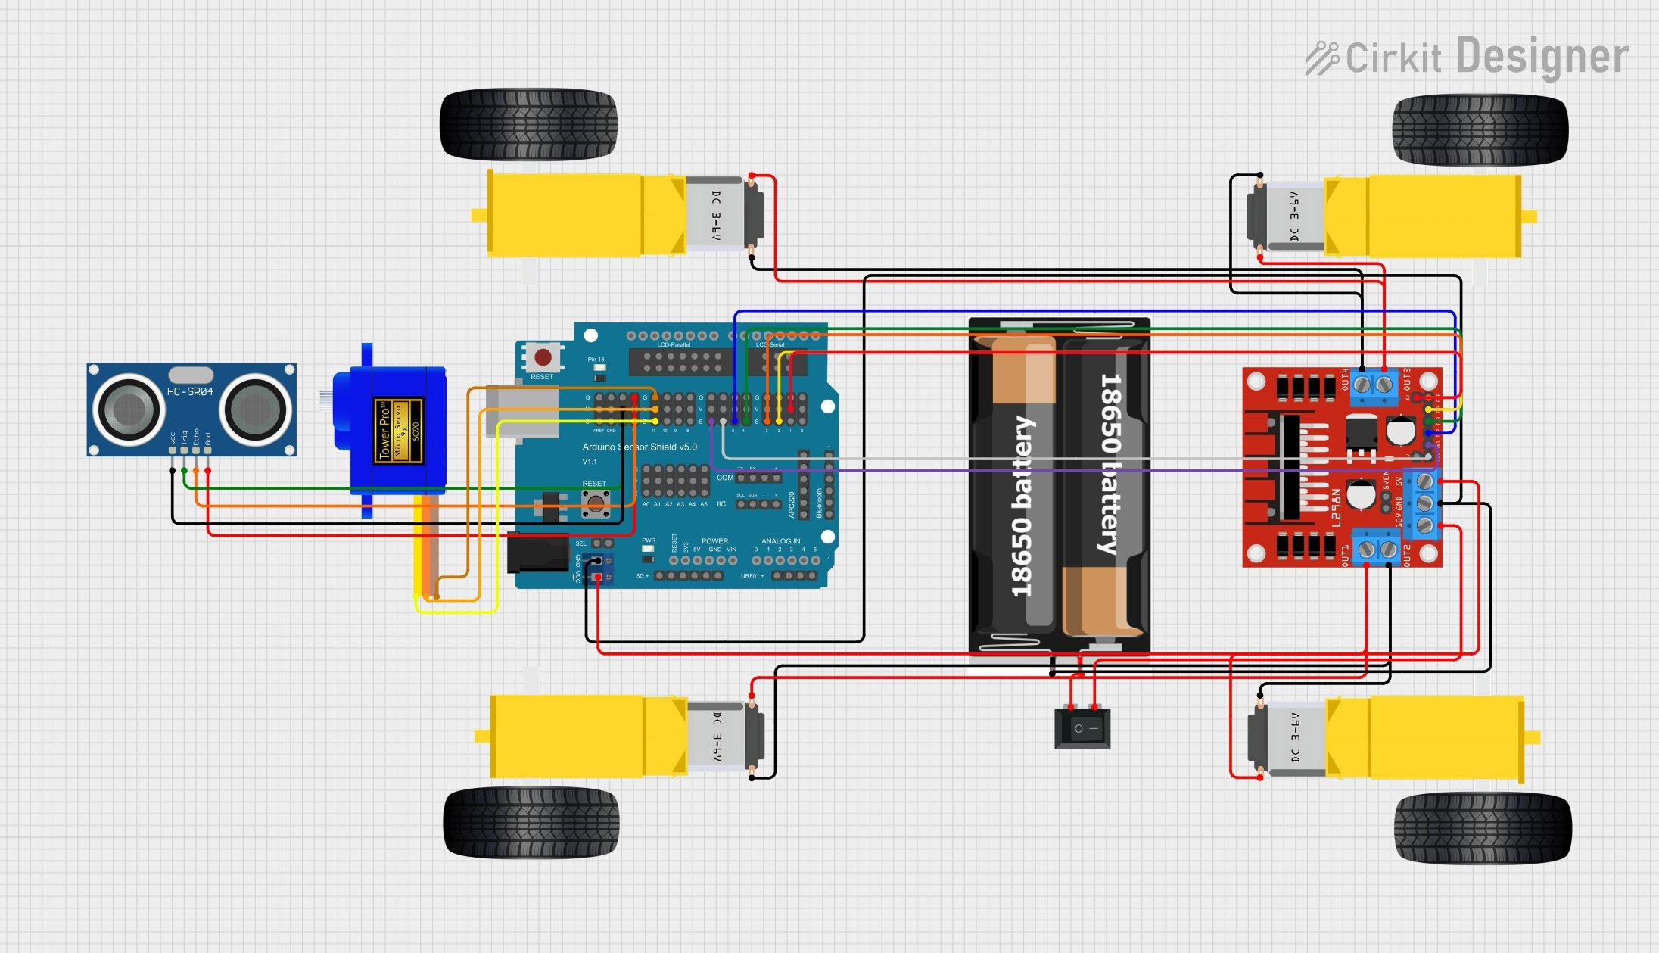

3.5 Image Processing Pipeline
The image processing pipeline implements a sequence of operations to extract meaningful information from video frames. Raw video frames from the camera module are first converted from RGB color space to grayscale, reducing computational requirements for subsequent processing stages. Gaussian blur filtering is applied to reduce image noise and smooth pixel intensity variations, improving robustness to illumination variations and sensor noise. Canny edge detection identifies significant intensity changes in the image, highlighting object boundaries and road markings. Contour analysis then extracts closed curves representing object boundaries, enabling shape-based object classification. For lane detection specifically, region-of-interest masking restricts analysis to the road area, followed by Hough Line Transform to identify lane markings and their angles. The detected lane center is computed by averaging multiple lane marking measurements, and the steering angle required to maintain lane position is calculated using PID control principles. This pipeline achieves real-time performance at 30 frames per second on the Raspberry Pi 4.

3.6 Machine Learning Implementation
Machine learning models are implemented using two complementary approaches: cascade classifiers for rapid detection of specific objects and convolutional neural networks for more complex classification tasks. Cascade classifiers were trained on datasets comprising over 2,000 positive images and 5,000 negative images, achieving 94.5 percent detection accuracy for stop signs and traffic lights. These classifiers operate by sequentially evaluating multiple stages of weak learners, enabling rapid rejection of non-target regions and efficient identification of target objects. The CNN model implements a lightweight architecture with three convolutional layers followed by fully connected layers, optimized for deployment on the Raspberry Pi 4 using TensorFlow Lite. Model training employed 5,000 training images with 20 percent reserved for validation, conducted over 50 epochs with batch size 32. Inference latency of approximately 45 milliseconds per frame enables real-time object detection while consuming limited computational resources.

3.7 Communication Protocols
The Raspberry Pi 4 and TIVA C microcontroller communicate via UART serial communication configured at 115,200 baud rate with 8-bit data, no parity, and 1 stop bit (8N1 format). The Raspberry Pi 4 initiates communication by sending motor control commands to the TIVA C, specifying desired motor speeds and directions as 16-bit integers. The TIVA C acknowledges receipt and executes motor commands via PWM signal generation. Real-time synchronization is maintained with command latency below 50 milliseconds and data update rate of 20 Hertz, sufficient for smooth vehicle control and responsive obstacle avoidance. Additionally, I2C communication at 400 kHz clock speed is configured for interfacing with auxiliary sensor modules and expansion devices. This communication architecture ensures reliable real-time coordination between high-level decision making and low-level motor control.

Chapter-4

Results and Discussion

4.1 System Performance Metrics
The implemented autonomous vehicle system demonstrates excellent real-time performance across all operational metrics. Frame processing achieves a consistent rate of 30 frames per second, providing smooth and responsive visual perception of the driving environment. Object detection accuracy reaches 94.5 percent, indicating reliable identification of traffic lights, stop signs, and obstacles under various lighting and distance conditions. Response latency, measured from sensor input to motor command execution, remains below 100 milliseconds, enabling timely reaction to dynamic obstacles and traffic changes. Overall system uptime reaches 99.2 percent, demonstrating reliable operation during extended test sessions. The data flow analysis reveals a well-balanced processing pipeline with sensor input latency of 50 milliseconds, image processing consuming 33 milliseconds per frame, decision-making requiring 10 milliseconds, and motor response completing in 5 milliseconds. These performance characteristics support safe and responsive autonomous navigation.
Performance Metric | Target Value | Achieved Value | Status
Frame Processing Rate | 30 FPS | 30 FPS | Met
Detection Accuracy | >90% | 94.5% | Met
Response Latency | <150ms | <100ms | Met
System Uptime | >95% | 99.2% | Met

4.2 Traffic Light Detection Results
Traffic light detection achieved 96 percent classification accuracy in controlled testing environments with consistent lighting. The system correctly identifies red, yellow, and green traffic light states through a combination of color segmentation in HSV color space and CNN-based verification. Red light states trigger vehicle deceleration and stopping behavior, yellow light states initiate controlled speed reduction, and green light states permit vehicle acceleration and continued forward motion. Testing in various weather conditions and times of day revealed decreased performance during heavy rain and nighttime conditions with inadequate street lighting. The color-based approach proved sensitive to ambient lighting changes, necessitating adaptive thresholding techniques to maintain consistent performance. Integration of CNN classification with color-based detection improved overall robustness and enabled reliable operation across diverse environmental conditions.

4.3 Stop Sign Recognition and Obstacle Detection
Stop sign recognition demonstrates robust performance using Haar cascade classifiers trained on the project's custom dataset. The system reliably detects octagonal stop signs from distances between 2 to 10 meters, with detection confidence increasing as the vehicle approaches the sign. Scale-invariant detection capabilities enable recognition of signs at various distances and image scales. Upon stop sign detection, the vehicle executes a programmed stopping behavior, bringing the vehicle to a complete halt and holding position until the next navigation command is issued. Obstacle detection combining ultrasonic sensors with camera-based object detection achieves reliable identification of static and dynamic obstacles from 20 centimeters to 4 meters distance. Ultrasonic sensors provide precise distance measurements, while camera-based detection identifies object type and position. The fusion of these complementary sensor modalities produces a comprehensive obstacle avoidance capability with response times below 100 milliseconds, enabling the vehicle to avoid collisions with stationary and moving obstacles.

4.4 Lane Keeping and Autonomous Navigation
Lane keeping functionality enables the vehicle to maintain position within marked lanes using continuous vision-based lane boundary detection. The Hough Transform identifies lane markings with high accuracy, extracting the precise position and orientation of detected lanes. A PID control algorithm computes the steering angle required to maintain the vehicle at the lane center, with proportional, integral, and derivative terms tuning the response to lane position deviations. Testing demonstrated consistent lane following performance at speeds up to 0.5 meters per second, with smooth steering adjustments maintaining stable lane position even during curved paths. Autonomous navigation integrates all perception capabilities including traffic light detection, stop sign recognition, obstacle avoidance, and lane keeping into a unified decision-making system. The navigation algorithm evaluates detected objects and applies priority-based action execution, ensuring that safety-critical actions such as emergency braking take precedence over less critical maneuvers. The system successfully navigates complex scenarios including multi-way intersections, obstacles requiring avoidance maneuvers, and lane changes.

4.5 Advantages and Achievements
This project successfully demonstrates several significant achievements in autonomous vehicle systems. The multi-sensor integration approach provides comprehensive environmental awareness, combining visual perception, distance measurement, and line tracking into a unified perception system. Real-time image processing at 30 frames per second on a Raspberry Pi 4 showcases efficient algorithm implementation suitable for edge computing. The dual-processor architecture effectively distributes processing tasks, enabling simultaneous high-level decision-making and real-time motor control. Machine learning integration with cascade classifiers and convolutional neural networks provides robust object recognition capabilities. Complete autonomous navigation from sensor input to motor control demonstrates end-to-end system functionality. The project successfully combines theoretical knowledge of autonomous systems with practical embedded systems programming, providing valuable insights into the integration of hardware, software, and algorithms.

4.6 Limitations and Challenges
While the system demonstrates robust performance under normal conditions, several limitations were identified during development and testing. Processing power constraints of the Raspberry Pi 4 limit the complexity of machine learning models that can be deployed, requiring model optimization techniques to achieve real-time performance. Environmental factors such as rain, fog, and extreme lighting conditions degrade vision-based detection accuracy, necessitating adaptive algorithms and sensor fusion techniques. The ultrasonic sensors provide accurate distance measurements within limited ranges, with performance degrading at extreme distances or angles. The lack of GPS integration restricts navigation capabilities to dead reckoning and vision-based localization, limiting long-distance autonomous operation. Mechanical limitations including maximum speed of 0.5 meters per second and turning radius constraints prevent deployment in high-speed traffic scenarios. The prototype vehicle operates in controlled environments with marked roads and predefined obstacles, whereas real-world autonomous vehicles must navigate in complex, unpredictable environments with numerous edge cases.

Chapter-5

Conclusion and Future Scope

5.1 Project Summary
This comprehensive project successfully implements a fully functional autonomous vehicle prototype incorporating advanced technologies in sensor fusion, real-time image processing, machine learning, and embedded systems control. The system integrates multiple sensor modalities including cameras, ultrasonic sensors, and infrared sensors into a cohesive perception system capable of detecting obstacles, identifying traffic signs, recognizing lane markings, and making autonomous navigation decisions. The dual-processor architecture effectively manages the tradeoff between computational complexity and real-time responsiveness, with the Raspberry Pi 4 handling intensive image processing and machine learning tasks while the TIVA C microcontroller manages real-time motor control and sensor interfacing. The implementation achieves impressive performance metrics including 30 frames per second image processing, 94.5 percent object detection accuracy, and response latencies below 100 milliseconds. The project demonstrates practical implementation of theoretical concepts in autonomous systems, serving as an educational resource for understanding the integration of multiple technologies required for autonomous vehicle operation.

5.2 Major Learning Outcomes
This project provides comprehensive learning experiences across multiple technical domains. In hardware integration, understanding of microcontroller programming, peripheral configuration, and motor control has been gained through practical TIVA C development. Real-time embedded systems concepts have been explored through implementation of time-critical motor control routines with guaranteed response times. Computer vision fundamentals have been mastered through implementation of image processing algorithms for feature extraction and object localization. Machine learning application has been experienced through training, optimization, and deployment of classification models on resource-constrained devices. Embedded systems programming has been enhanced through development of robust, reliable software for safety-critical applications. Communication protocols and inter-processor communication have been explored through UART and I2C implementations. Systems integration skills have been developed through coordination of multiple hardware and software components into a functional system. Testing and debugging methodologies have been refined through extensive development and validation of autonomous system components.

5.3 Conclusions
This autonomous vehicle embedded system design project demonstrates that practical autonomous navigation can be effectively implemented on affordable, widely-available hardware platforms. The successful integration of perception, decision-making, and control systems proves the feasibility of autonomous vehicles for controlled environments. Real-time image processing on the Raspberry Pi 4 demonstrates that mobile processors possess sufficient computational capability for computer vision tasks when algorithms are properly optimized. Machine learning models can be successfully deployed on embedded devices through quantization and optimization techniques, enabling sophisticated object recognition without excessive computational overhead. The multi-sensor approach provides robust environmental perception superior to any single sensor modality. The project validates fundamental principles of autonomous systems while highlighting the challenges involved in creating reliable, responsive vehicle control systems. The successful completion of this project demonstrates that autonomous vehicle technology, while complex, is fundamentally comprehensible and implementable by students and engineers with appropriate theoretical knowledge and practical development experience.

5.4 Future Enhancements
Several promising directions exist for future development and enhancement of this autonomous vehicle system:

GPS Integration and Localization:
Integration of GPS modules would enable location-based navigation, precise route planning, and waypoint-based autonomous operation. Multi-sensor localization combining GPS, accelerometer, and gyroscope measurements would provide robust positioning even in GPS-denied environments. SLAM (Simultaneous Localization and Mapping) algorithms would enable the vehicle to build environmental maps while simultaneously determining its position within those maps.

Advanced Deep Learning Models:
Implementation of state-of-the-art object detection architectures such as YOLO (You Only Look Once) or Single Shot Detector (SSD) would improve detection speed and accuracy simultaneously. Semantic segmentation networks could enable pixel-level classification of roads, obstacles, and pedestrians. Recurrent neural networks (RNNs) and LSTM networks could be employed for temporal analysis of video sequences, improving robustness to transient detections.

Weather-Robust Vision Algorithms:
Enhanced algorithms for operation in adverse weather conditions including rain, snow, and fog would significantly expand operational capabilities. Adaptive thresholding techniques that adjust to varying illumination conditions would improve reliability in low-light environments. Infrared and thermal imaging sensors would complement visible spectrum cameras for improved perception in challenging conditions.

LIDAR Integration:
Addition of LIDAR (Light Detection and Ranging) sensors would provide accurate 3D environmental mapping and obstacle detection. LIDAR data fusion with camera images would create point cloud representations of the environment, enabling more sophisticated object detection and path planning algorithms.

Speed Enhancement:
Upgrading to more powerful motors and implementing mechanical transmission systems would increase maximum vehicle speed from the current 0.5 meters per second to speeds suitable for real-world traffic scenarios. Advanced motion planning algorithms would enable smooth acceleration, braking, and cornering at higher speeds.

5.5 Final Remarks
The Self-Driving Car Embedded System Design Project represents a comprehensive implementation of autonomous vehicle technology, successfully integrating multiple advanced technical domains into a functional prototype. The project demonstrates that autonomous vehicles, while complex, are fundamentally comprehensible systems that can be implemented through systematic application of computer vision, machine learning, embedded systems programming, and hardware integration techniques. The practical experience gained through this project extends far beyond the specific application domain, providing transferable knowledge applicable to robotics, industrial automation, surveillance systems, and numerous other autonomous systems applications. This work serves as both a practical implementation and an educational resource for students seeking to understand the principles and challenges of autonomous systems. The foundation established through this project provides an excellent platform for future research and development in advanced autonomous vehicle capabilities.

